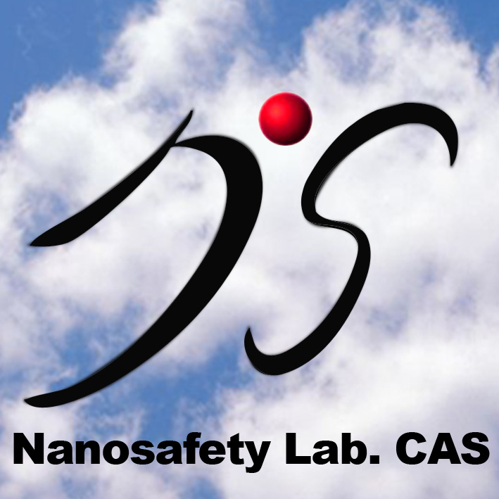

Tel: +86-10-8823-6709
Fax: +86-10-8823-3191
http://www.nanosafety.cas.cn

Branch Ⅱ
National Center for Nanosciences&Technology No.11 ZhongGuanCun BeiYiTiao,
Beijing 100190, China

BranchⅠ
Institute of High Energy Physics,
YuQuan Rd 19B, P. O. Box 918,
Beijing 100049, China

Chinese Academy of Sciences
Key Lab for Biomedical Effects of Nanomaterials and Nanosafety

